CISCO NSO
End-to-End Acceptance Test
Executive Summary & Demonstration Report

Environment: 172.28.2.17 | LSA Deployment (RFS/CFS)

1. Purpose
This report confirms that the Cisco NSO (Network Services Orchestrator) platform has been installed, configured, and verified end-to-end. NSO is the automation system that allows the network team to set up and manage customer internet/fiber connections without manual, device-by-device configuration.
A complete acceptance test was carried out — from confirming the system is running, through submitting a real customer service order, to confirming the physical field device was activated and the order could be safely removed. Every check passed.

2. What This Means for the Business
- Faster service activation: New customer fibre connections can be provisioned automatically instead of manually configured on each device.
- Reduced human error: Standardized, repeatable automation reduces the risk of misconfiguration in the field.
- Full traceability: Every order is logged and visible in the web dashboard for audit and support purposes.
- Safe operations: The system can also cleanly reverse (delete) an order, confirming rollback safety before this goes into full production use.

3. Test Results Summary
The table below summarizes each verification step performed and its outcome. Full technical evidence (screenshots) for each step is provided in Section 4.
# | Checkpoint | What It Confirms | Result
1 | System Health Check | Confirmed the orchestration platform (NSO) is running and available. | PASS
2 | Administrator Access | Confirmed authorized staff can securely log in to the system. | PASS
3 | Network Device Connectivity | Confirmed the platform can reach and communicate with field network devices (OLTs). | PASS
4 | Automation Package Check | Confirmed the provisioning automation package is correctly installed and active. | PASS
5 | Service Order Submission | A real customer service order (fibre connection setup) was submitted for processing. | PASS
6 | Order Processing | The order was processed and committed successfully with no errors. | PASS
7 | Web Portal Verification | The committed order was confirmed visible in both business and network-facing web dashboards. | PASS
8 | Audit Log Verification | System logs correctly recorded the full transaction for traceability. | PASS
9 | Field Device Provisioning | Confirmed the physical field device (OLT) was actually configured to activate service. | PASS
10 | Delete | Confirmed the system can cleanly remove a service order, proving safe rollback capability. | PASS

4. Detailed Walkthrough (For Demonstration)
This section presents the evidence in the same order the demo can be walked through live, with plain-language explanations for each screen.

Step 1 — System is Up and Running
The NSO server status check shows the platform is active and reports its version — confirming the system is healthy before any work begins.
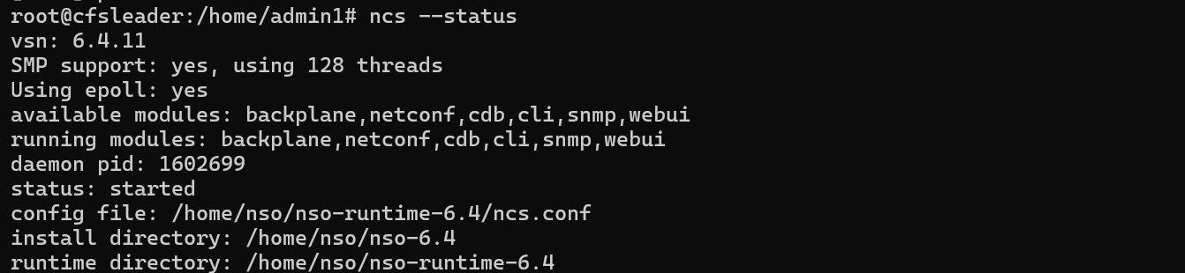
NSO status check confirming the platform is running.

Step 2 — Administrator Login
An authorized administrator logs into the NSO command interface, demonstrating controlled, secure access to the platform.
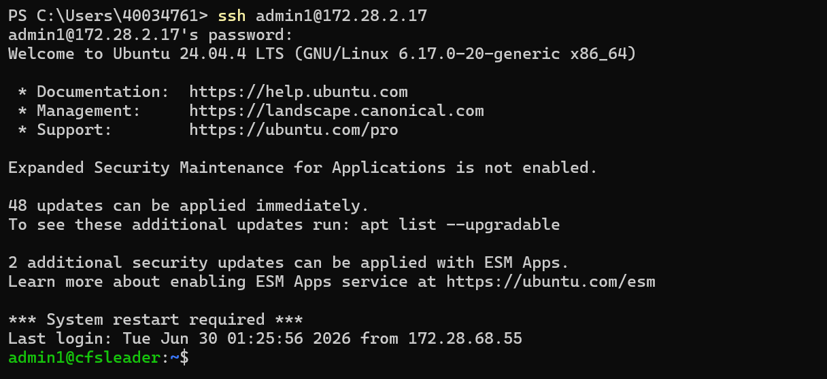
Administrator logging into the NSO CLI.

Step 3 — Network Devices Are Reachable
The system confirms it can see and communicate with the field devices (OLTs) it needs to manage — a prerequisite for any automated provisioning.
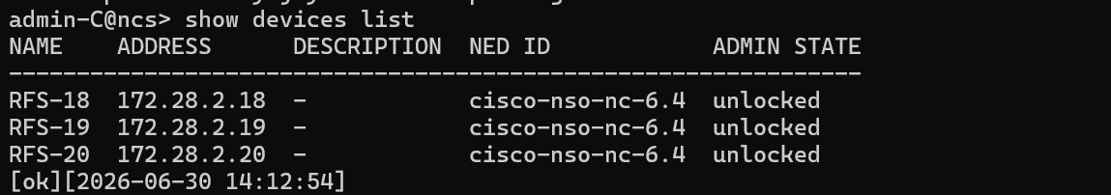
Device connectivity list confirming reachable network devices.

Step 4 — Automation Package Is Active
The service package that drives automated provisioning is confirmed loaded and operational on the platform.
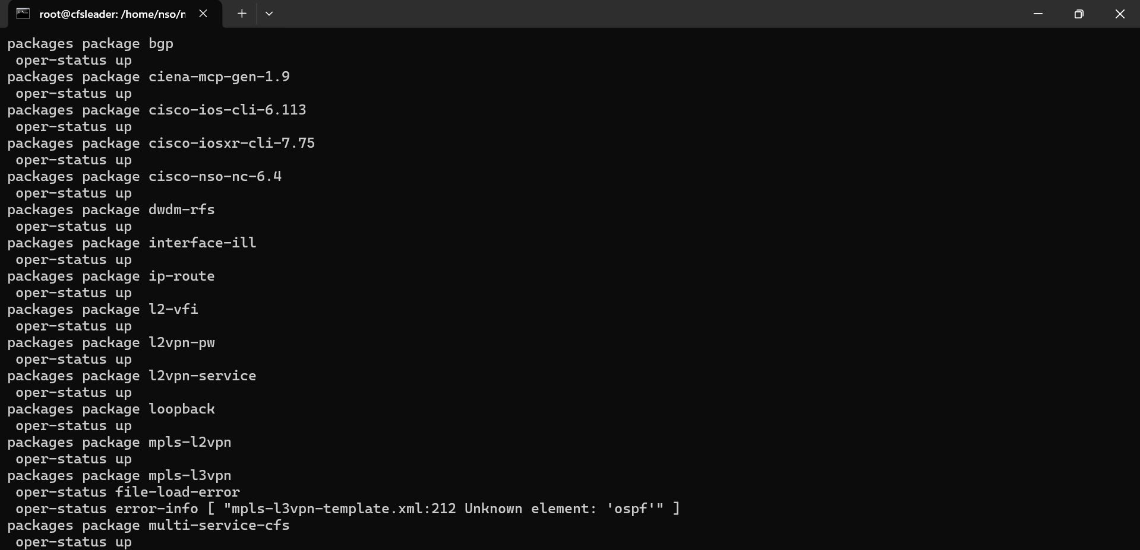
Service package operational status — confirmed active.

Step 5 & 6 — Service Order Submitted and Processed Successfully
A real service order was submitted, containing the customer and connection details (device, package, VLAN, bandwidth profile, etc.). The system processed and committed the order without errors.
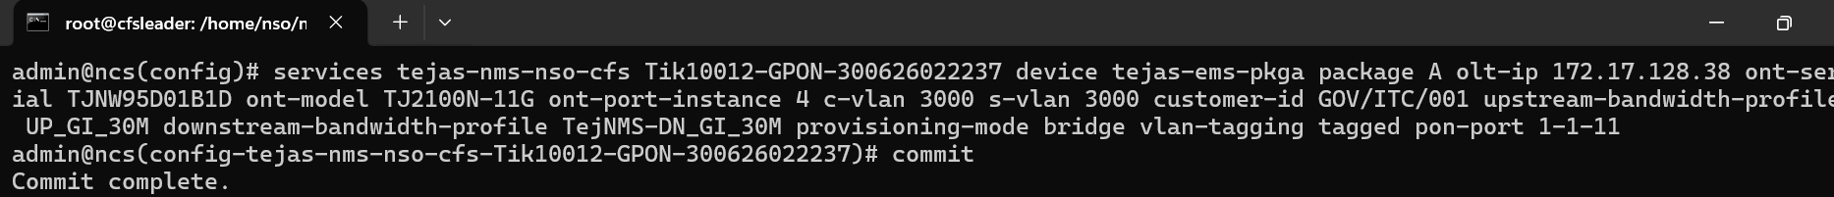
Confirmation that the order committed successfully.

Step 7 — Order Visible in the Web Dashboard
The completed order is visible in the web portal from both the customer-facing (CFS) and network-facing (RFS) views, giving staff a simple way to track orders without using the command line.
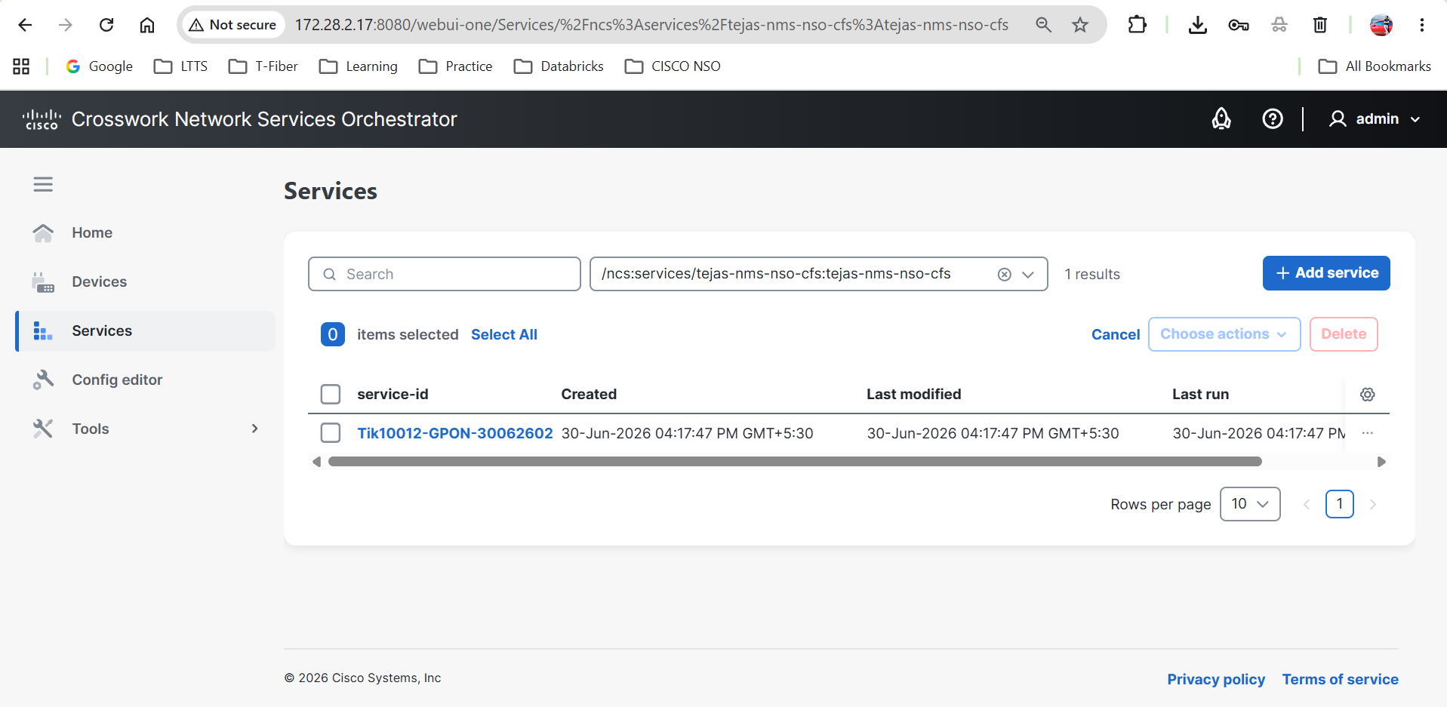
Order visible in the customer-facing (CFS) web dashboard.
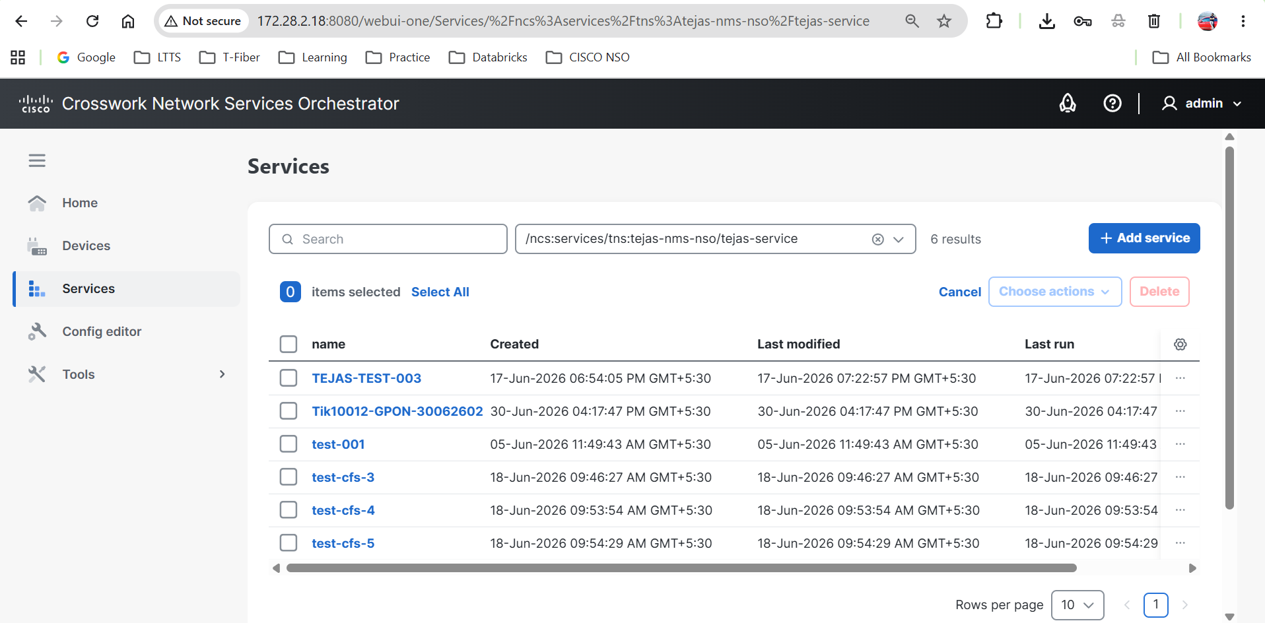
Order visible in the network-facing (RFS) web dashboard.

Step 8 — Field Device Provisioned
Beyond the software confirmation, the actual field device (OLT) in the Tejas EMS system was confirmed configured — meaning the customer's service would genuinely go live.
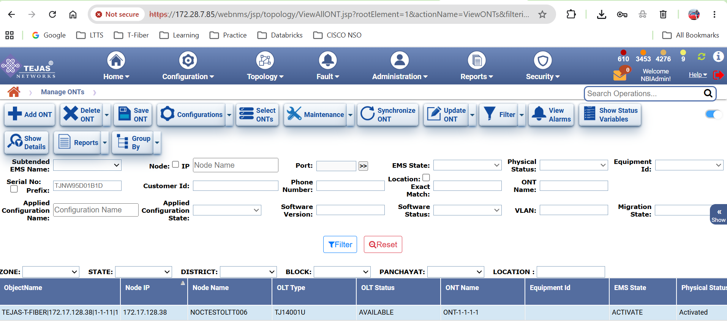
OLT provisioning confirmed in the Tejas EMS field management system.

Step 9 — Safe Rollback Verified
Finally, the order was deleted to confirm the system can cleanly remove a service when needed (e.g., cancellations or corrections), without leaving the platform in an inconsistent state.
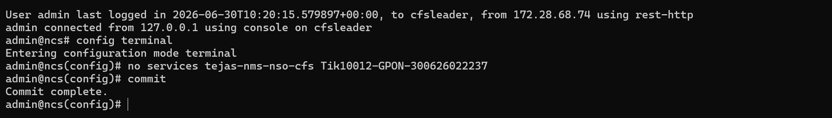
Confirmation that the committed order was successfully deleted.

5. Conclusion
All ten checkpoints across system health, security, connectivity, automation, order processing, dashboard visibility, and rollback were verified successfully.

